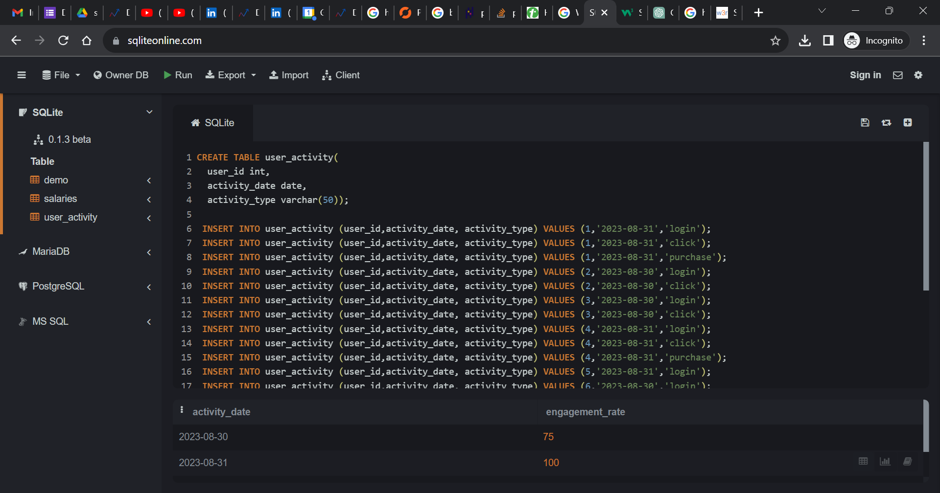

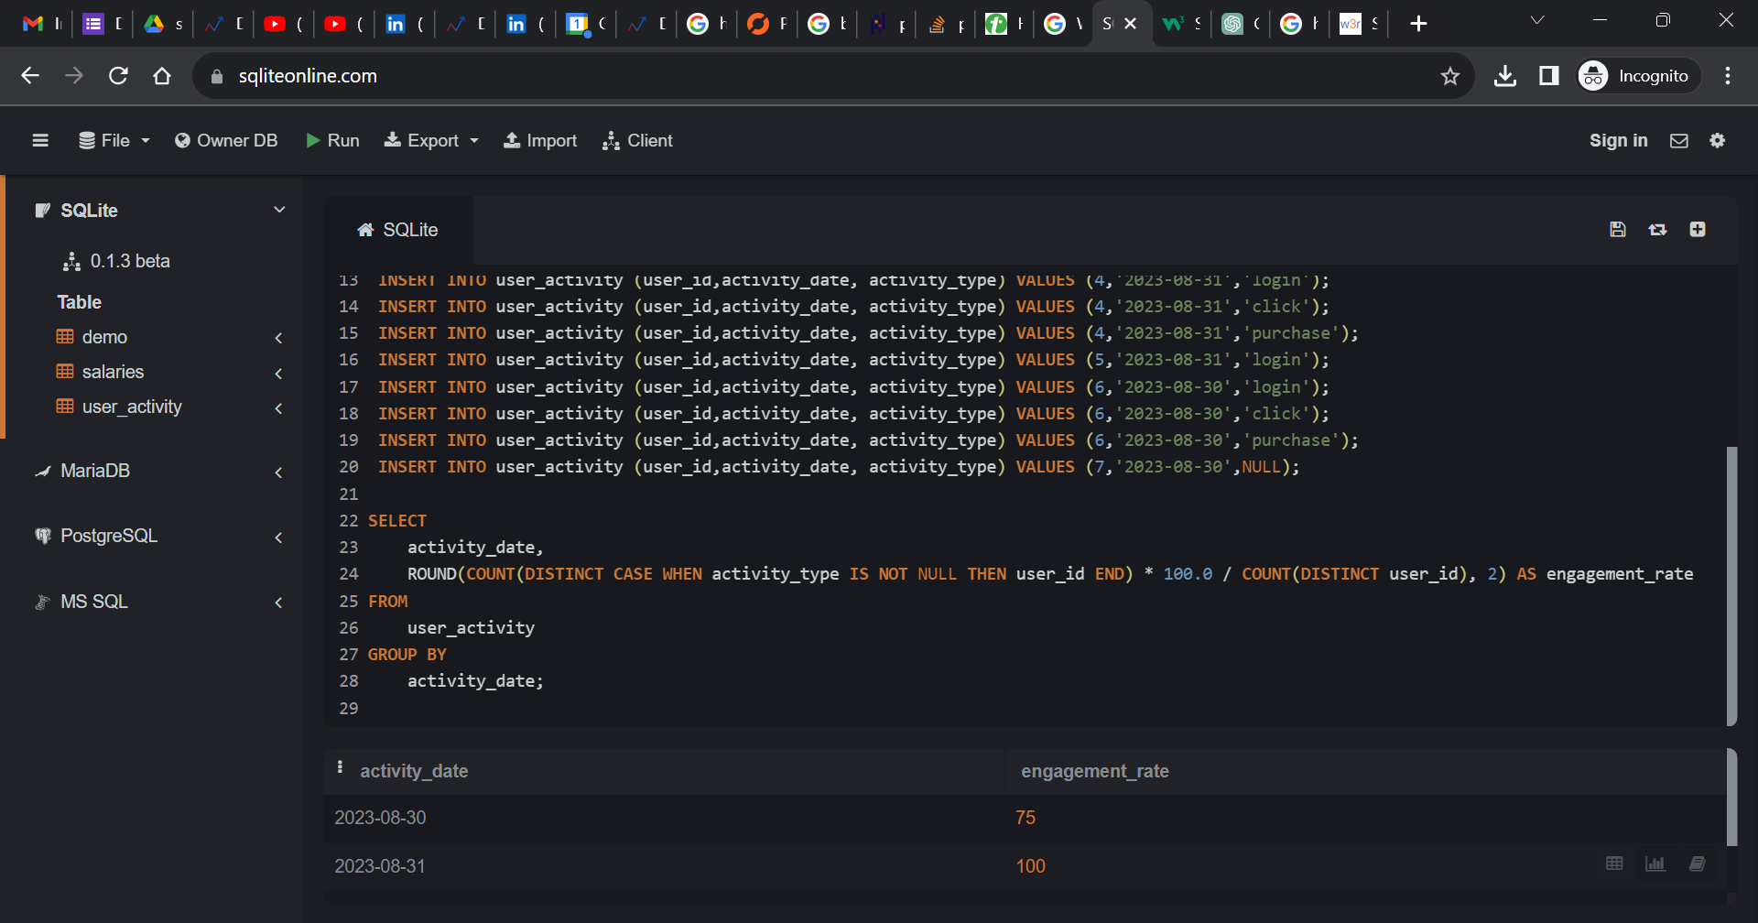

create table user_activity(

user_id int,

activity_date date,

activity_type varchar(50));

insert into user_activity (user_id,activity_date, activity_type) values (1,'2023-08-31','login');

insert into user_activity (user_id,activity_date, activity_type) values (1,'2023-08-31','click');

insert into user_activity (user_id,activity_date, activity_type) values (1,'2023-08-31','purchase');

insert into user_activity (user_id,activity_date, activity_type) values (2,'2023-08-30','login');

insert into user_activity (user_id,activity_date, activity_type) values (2,'2023-08-30','click');

insert into user_activity (user_id,activity_date, activity_type) values (3,'2023-08-30','login');

insert into user_activity (user_id,activity_date, activity_type) values (3,'2023-08-30','click');

insert into user_activity (user_id,activity_date, activity_type) values (4,'2023-08-31','login');

insert into user_activity (user_id,activity_date, activity_type) values (4,'2023-08-31','click');

insert into user_activity (user_id,activity_date, activity_type) values (4,'2023-08-31','purchase');

insert into user_activity (user_id,activity_date, activity_type) values (5,'2023-08-31','login');

insert into user_activity (user_id,activity_date, activity_type) values (6,'2023-08-30','login');

insert into user_activity (user_id,activity_date, activity_type) values (6,'2023-08-30','click');

insert into user_activity (user_id,activity_date, activity_type) values (6,'2023-08-30','purchase');

insert into user_activity (user_id,activity_date, activity_type) values (7,'2023-08-30',NULL);

SELECT

activity_date,

ROUND(COUNT(DISTINCT CASE WHEN activity_type IS NOT NULL THEN user_id END) * 100.0 / COUNT(DISTINCT user_id), 2) AS engagement_rate

FROM

user_activity

GROUP BY